Driver Behaviour Intelligence (DBI) System

In this system we place a set of sensors in the seat and the steering to find the siting posture and steering wheel movement, Based on the above sensor reading our micro controller unit will estimate the driver behaviour is fit for a safe ride, if there is any Driver Behaviour problems our sensors will accurately detect the scenario and provide necessary warning to the driver through an alert sound and an LCD Display.

Here in this system we are using a Potentiometer to detect the steering position and we use a set of force sensors to estimate the sating posture of the driver

Arduino

LCD Display

Safety Switch

Force Sensor

Potentiometer

Buzzer

Sleep detection AI

Arduino UNO

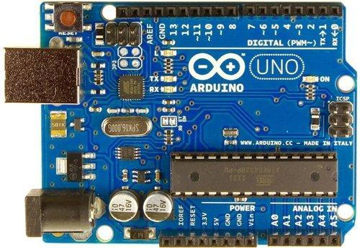

**Arduino Uno** is a microcontroller board based on the ATmega328P ([datasheet](http://ww1.microchip.com/downloads/en/DeviceDoc/Atmel-7810-Automotive-Microcontrollers-ATmega328P_Datasheet.pdf)). It has 14 digital input/output pins (of which 6 can be used as PWM outputs), 6 analog inputs, a 16 MHz ceramic resonator (CSTCE16M0V53-R0), a USB connection, a power jack, an ICSP header and a reset button

**General pin functions**

* LED: There is a built-in LED driven by digital pin 13. When the pin is high value, the LED is on, when the pin is low, it is off.
* VIN: The input voltage to the Arduino/Genuino board when it is using an external power source (as opposed to 5 volts from the USB connection or other regulated power source). You can supply voltage through this pin, or, if supplying voltage via the power jack, access it through this pin.
* 5V: This pin outputs a regulated 5V from the regulator on the board. The board can be supplied with power either from the DC power jack (7 - 20V), the USB connector (5V), or the VIN pin of the board (7-20V). Supplying voltage via the 5V or 3.3V pins bypasses the regulator, and can damage the board.
* 3V3: A 3.3 volt supply generated by the on-board regulator. Maximum current draw is 50 mA.
* GND: Ground pins.
* IOREF: This pin on the Arduino/Genuino board provides the voltage reference with which the microcontroller operates. A properly configured shield can read the IOREF pin voltage and select the appropriate power source, or enable voltage translators on the outputs to work with the 5V or 3.3V.
* Reset: Typically used to add a reset button to shields that block the one on the board.

**Special pin functions**

Each of the 14 digital pins and 6 analog pins on the Uno can be used as an input or output, under software control (using pinMode(), digitalWrite(), and digitalRead() functions). They operate at 5 volts. Each pin can provide or receive 20 mA as the recommended operating condition and has an internal pull-up resistor (disconnected by default) of 20-50K ohm. A maximum of 40mA must not be exceeded on any I/O pin to avoid permanent damage to the microcontroller. The Uno has 6 analog inputs, labeled A0 through A5; each provides 10 bits of resolution (i.e. 1024 different values). By default, they measure from ground to 5 volts, though it is possible to change the upper end of the range using the AREF pin and the analogReference() function.

In addition, some pins have specialized functions:

* Serial / [UART](https://en.wikipedia.org/wiki/UART): pins 0 (RX) and 1 (TX). Used to receive (RX) and transmit (TX) TTL serial data. These pins are connected to the corresponding pins of the ATmega8U2 USB-to-TTL serial chip.
* External interrupts: pins 2 and 3. These pins can be configured to trigger an interrupt on a low value, a rising or falling edge, or a change in value.
* [PWM](https://en.wikipedia.org/wiki/Pulse-width_modulation) (pulse-width modulation): pins 3, 5, 6, 9, 10, and 11. Can provide 8-bit PWM output with the analogWrite() function.
* [SPI](https://en.wikipedia.org/wiki/Serial_Peripheral_Interface) (Serial Peripheral Interface): pins 10 (SS), 11 (MOSI), 12 (MISO), and 13 (SCK). These pins support SPI communication using the SPI library.
* TWI (two-wire interface) / [I²C](https://en.wikipedia.org/wiki/I%C2%B2C): pin SDA (A4) and pin SCL (A5). Support TWI communication using the Wire library.
* AREF (analog reference): Reference voltage for the analog inputs.

# SPST Momentary Push Button

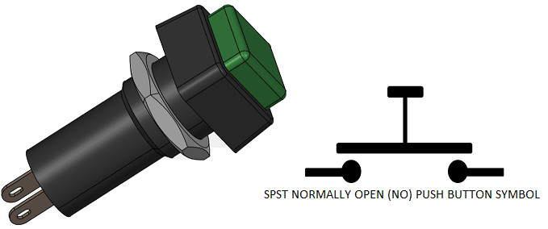

Push buttons are used in applications which requires momentary ON or OFF switching action. Normally Open Push button switch are initially in OFF state as the contacts are not in contact with each and when pushed down the contacts gets closed and the path established between the two terminals of the push button.

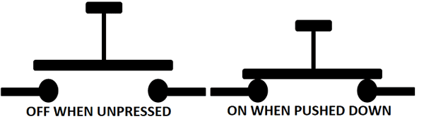

**16*2 LCD Display**

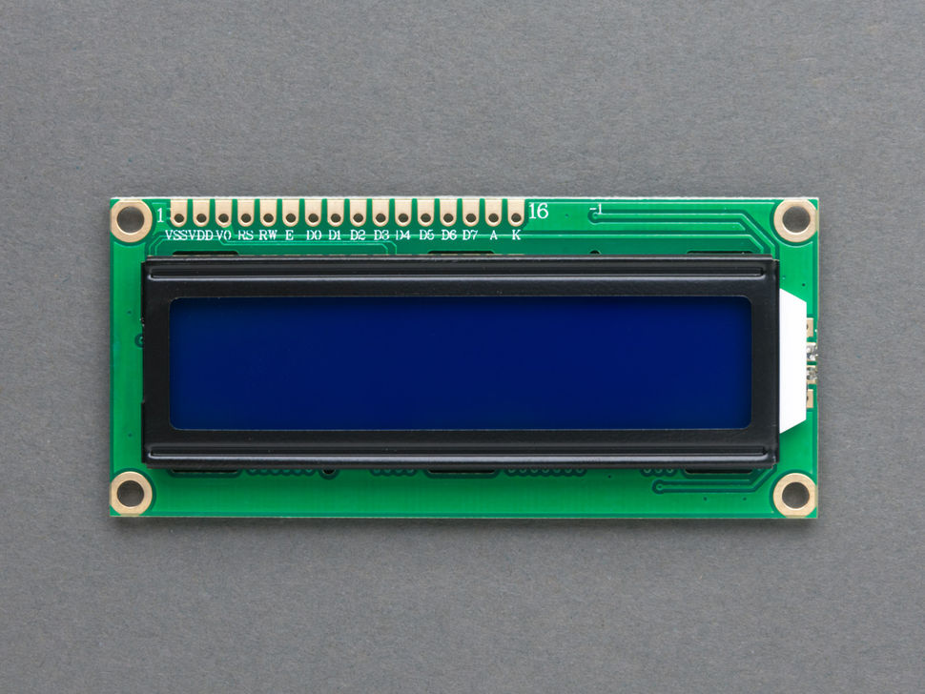

An LCD (Liquid Crystal Display) screen is an electronic display module and has a wide range of applications. A 16x2 LCD display is very basic module and is very commonly used in various devices and circuits. A 16x2 LCD means it can display 16 characters per line and there are 2 such lines. In this LCD each character is displayed in 5x7 pixel matrix. The 16 x 2 intelligent alphanumeric dot matrix display is capable of displaying 224 different characters and symbols. This LCD has two registers, namely, Command and Data.

Command register stores various commands given to the display. Data register stores data to be displayed. The process of controlling the display involves putting the data that form the image of what you want to display into the data registers, then putting instructions in the instruction register. In your arduino project [Liquid Crystal Library](https://www.arduino.cc/en/Reference/LiquidCrystal) simplifies this for you so you don't need to know the low-level instructions. Contrast of the display can be adjusted by adjusting the potentiometer to be connected across VEE pin.

|  |  |  |
| --- | --- | --- |
| **Pin number** | **name** | **Description** |
| 1 | Ground/Source Pin | This is a GND pin of display, used to connect the GND terminal of the microcontroller unit or power source. |
| 2 | VCC/Source Pin | This is the voltage supply pin of the display, used to connect the supply pin of the power source. |
| 3 | V0/VEE/Control Pin | Adjusts the contrast of the LCD. |
| 4 | Register Select | This pin toggles among command or data register, used to connect a microcontroller unit pin and obtains either 0 or 1(0 = data mode, and 1 = command mode). |
| 5 | Read/Write/Control Pin | This pin toggles the display among the read or writes operation, and it is connected to a microcontroller unit pin to get either 0 or 1 (0 = Write Operation, and 1 = Read Operation). |
| 6 | Enable/Control Pin | This pin should be held high to execute Read/Write process, and it is connected to the microcontroller unit & constantly held high. |
| 7 to 14 | Data Pins | These pins are used to send data to the display. These pins are connected in two-wire modes like 4-wire mode and 8-wire mode. In 4-wire mode, only four pins are connected to the microcontroller unit like 0 to 3, whereas in 8-wire mode, 8-pins are connected to microcontroller unit like 0 to 7. |
| 15 an16 | Back light | 15 LED positive,16 LED Negative |

## Force Sensor

Sir Franklin Eventoff, in the 1970s, found some materials, when subjected to force, can change their resistance values. These materials were known as Force-Sensing Resistors. These materials are used to produce a sensor that can measure the Force. A Force Sensor is a sensor that helps in measuring the amount of force applied to an object. By observing the amount of change in the resistance values of force-sensing resistors, the applied force can be calculated.

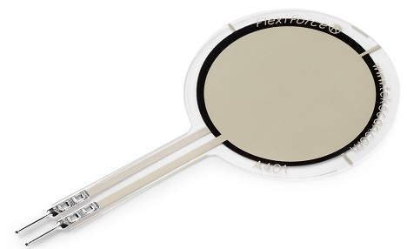Force-Sensor

### Working Principle

The general working principle of Force Sensors is that they respond to the applied force and convert the value into a measurable quantity. There are various types of Force Sensors available in the market based on various sensing elements. Most of the Force Sensors are designed using Force-Sensing Resistors. These sensors consist of a sensing film and electrodes.

The working principle of a Force-sensing resistor is based on the property of ‘Contact Resistance’. Force-sensing resistors contain a conductive polymer film that changes its resistance in a predictable manner when force is applied on its surface. This film consists of, sub-micrometres sized, electrically conducting and non-conducting particles arranged in a matrix. When force is applied to the surface of this film, the microsized particle touches the sensor electrodes, changing the resistance of the film. The amount of change caused to the resistance values gives the measure of the amount of force applied.

To improve the performance of the Force-Sensing resistors various efforts are being made with multiple different approaches such as, to minimize the drift of polymer various electrode configurations are being tested, testing with sensor by replacing the polymer with new materials such as carbon nanotubes, etc….